**Annex 1: Guidelines for Applicants Open Call #1.4 PULL**

September/2021

**Disclaimer**

This document may contain material that is copyright of certain HUBCAP Consortium Partners and may not be reproduced or copied without permission. All HUBCAP consortium partners have agreed to the full publication of this document. The commercial use of any information contained in this document may require a license from the proprietor of that information.

Table : List of partners from the HUBCAP Consortium.

|  |  |  |  |
| --- | --- | --- | --- |
| **HUBCAP Consortium** | | | |
| **Participant Number** | **Participant organisation name** | **Short**  **name** | **Country** |
| 1 | Aarhus University | AU | Denmark |
| 2 | Newcastle University | UNEW | UK |
| 3 | fortiss | FOR | Germany |
| 4 | Virtual Vehicle Research Center | VV | Austria |
| 5 | Fundazione Bruno Kessler | FBK | Italy |
| 6 | KTH Royal Instute of Technology | KTH | Sweden |
| 7 | University “Lucian Blaga” of Sibiu | ULBS | Romania |
| 8 | Engineering Ingegneria Informatica S.p.A. | ENGIT | Italy |
| 9 | Research Institutes of Sweden AB | RISE | Sweden |
| 10 | F6S Network Ireland Limited | F6S | Ireland |
| 11 | Politecnico di Milano | POLIMI | Italy |
| 12 | Unparallel Innovation | UNP | Portugal |
| 13 | Controllab Products | CLP | Netherlands |
| 14 | BEIA Consult | BEIA | Romania |
| 15 | Verified Systems International | VSI | Germany |
| 16 | Validas | VAL | Germany |
| 17 | Technology Transfer Systems srl | TTS | Italy |

The information in this document is provided “as is” and no guarantee or warranty is given that the information is fit for any particular purpose. The user thereof uses the information at its sole risk and liability.

Moreover, it is clearly stated that the HUBCAP consortium reserves the right to update, amend or modify any part, section, or detail of the document at any point in time without prior information.

The HUBCAP project, co-funded from the European Union’s Horizon 2020 research and innovation programme under grant agreement No 872698, foresees as an eligible activity the provision of financial support to third parties, to achieve its own objectives.

|  |
| --- |
| LEGAL NOTICE  The information and views set out in this application form are those of the author(s) and do not necessarily reflect the official opinion of the European Union. Neither the European Union institutions and bodies nor any person acting on their behalf may be held responsible for the use which may be made of the information contained therein. |

Funding Scheme: Innovation Action (IA) ● Theme: H2020-DT-2018-2020

Start date of project: 01 January 2020 ● Duration: 36 months

©HUBCAP Consortium, 2020

Reproduction is authorised provided the source is acknowledged.

**Table of contents**

1 Introduction 6

1.1 Background information on the HUBCAP project 6

1.2 HUBCAP approach 7

2 General information 8

2.1 Means of submission 8

2.2 Language 9

2.3 Data protection 9

2.4 Origin of the funds 10

3 Eligibility of applicants 10

3.1 Definition of SME 10

3.2 SME Eligibility Criteria 10

3.3 Application Eligibility Criteria 10

4 HUBCAP Open Call #1.4 PULL 11

4.1 Funding Scheme 11

4.2 Timeline 11

4.3 Application, Selection and Payment procedures 13

4.3.1 Submission 13

4.3.2 Asset Application Preparation 13

4.3.3 Asset Application Reception 14

4.4 Selection Process 14

4.4.1 Eligibility 14

4.4.2 Internal remote evaluation 14

4.4.3 Final Selection 15

4.4.4 Sub-Grant Agreement Preparation 15

4.4.5 Sub-Grant Agreement Signature 16

4.4.6 Redress process 16

5 Responsibilities of beneficiaries SMEs 17

6 Contacts 17

7 References 18

**List of Figures**

Figure 1:HUBCAP one-stop-shop for SMEs. 6

Figure 2: HUBCAP overall approach. 7

Figure 3: HUBCAP OCs overall concept and evaluation procedure. 8

Figure 4: Open Call #1.4 PULL activities timeline. 12

**List of Tables**

Table 1: List of partners from the HUBCAP Consortium. 2

Table 2: List of abbreviations and acronyms. 5

Table : List of abbreviations and acronyms.

|  |  |
| --- | --- |
| **List of Abbreviations and Acronyms** | |
| **HUBCAP** | Digital Innovation HUBs and Collaborative Platform for Cyber-Physical Systems |
| **CET** | Central European Time |
| **EC** | European Commission |
| **EU** | European Union |
| **MBD** | Model-Based Design |
| **CPS** | Cyber-Physical System |
| **RTD** | Research and Technological Development |
| **SME** | Small and Medium-sized enterprises (including start-ups) |
| **DIHs** | Digital Innovation Hubs |
| **TRL** | Technology Readiness Level |
| **VAT** | Value Added Tax |
| **OC** | Open Call |
| **OLAF** | European Anti-Fraud |
| **ESR** | Evaluation Summary Report |
| **AWU** | Annual Work Unit |
| **GDPR** | General Data Privacy Regulations |

# Introduction

This document provides a full set of information regarding the Open Call #1.4 PULL of the HUBCAP project (www.hubcap.eu). The Sub-Grant Agreement template (as given in *Annex 5*) must be additionally considered for the submission of an application to the Open Call #1.4 PULL.

HUBCAP will organise three sets of open calls (OCs) to select and directly finance SMEs to develop, experiment, integrate, and deploy new existing Model-Based Design (MBD) and Cyber-Physical Systems (CPS) technology through the application of high valuable experiments. These will include:

1. Call #1 PULL (Call #1.1; Call #1.2; Call #1.3; Call #1.4; Call #1.5)
2. Call #2 EXPERIMENT (Call #2.1; Call #2.2)
3. Call #3 INNOVATE (Call #3)

## Background information on the HUBCAP project

HUBCAP will provide a one-stop-shop for European SMEs wanting to join the Cyber-Physical Systems (CPS) revolution using Model-Based Design (MBD) techniques. It builds on seven established Digital Innovation Hubs (DIHs) in seven European countries, each embedded in its regional innovation ecosystem, offering complementary technical expertise, experimental capabilities, and specialist knowledge in CPS application domains. From this base, HUBCAP will create a growing and sustainable European network offering SMEs opportunities to undertake experiments, seek investment, access expertise and training, and form new business links. This is enabled by a cloud-based open collaboration platform with a ‘sandbox’ capability to help users’ trial new technology.

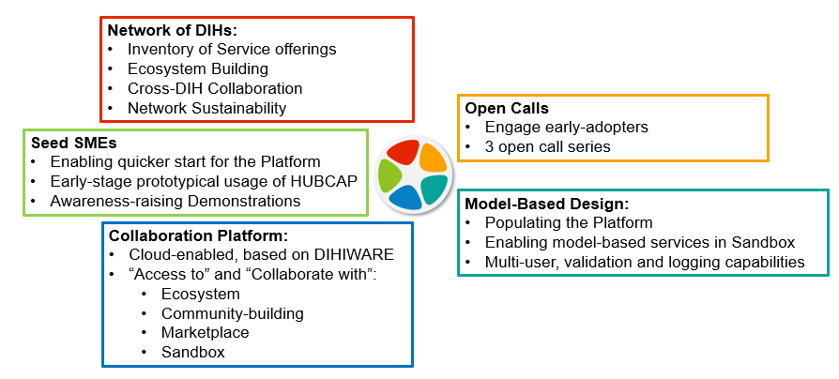

Figure 1:HUBCAP one-stop-shop for SMEs.

HUBCAP will lower barriers for SMEs to realise the potential of growing autonomy in CPSs by accessing advanced Model-Based Design (MBD) technology, providing training and guidance, and acting as a gateway to the full network of all registered DIHs specialising in CPS. Half the project funding will go to supporting SMEs, including open call funding for SMEs to join the ecosystem and experiment with MBD technology. HUBCAP will extend an existing open collaboration platform to enable SMEs to co-create, analyse, and validate new CPS products in a virtual setting, by accessing CPS assets (models, tools, services) and experimenting with new solutions, de-risking investments in skills or resources.

Technology providers will help populate and validate the initial collaboration platform and carefully selected seed SMEs will assist in kickstarting the ecosystem and reaching out to entirely new users of MBD technologies.

|  |
| --- |
| The vision of the Digital Innovation Hubs and Collaborative Platform for Cyber-Physical System (HUBCAP) project is to lower the initial costs for SMEs for using a MBD approach for the development of CPSs, delivering a sustainable network of SMEs, DIHs and other actors that enables and encourages suppliers and users of CPS models and MBD tools to meet and collaborate. This will be achieved by building an ecosystem around a cloud-based collaboration platform supported by DIHs and by the SMEs enhanced by Open Calls. |

The funding to third-party SMEs will enable the extension of the technology offer beyond consortium partners (even opening the space for other H2020 competitor proposals with different technologies to engage with HUBCAP) and enlarge the outreach of the large-scale pilots by supporting the deployment of new pilots in different geographic regions.

## HUBCAP approach

HUBCAP aims to create a sustainable ecosystem based on three key elements.

**First**, it will create a sustainable network from existing Digital Innovation Hubs (DIHs) with complementary competencies in CPS design and from a range of European countries. This network will build up an innovation ecosystem with the help of innovative seed SMEs.

**Second**, HUBCAP will run a programme of open calls to pull SMEs into the ecosystem (Call #1 PULL), to allow them to experiment with new technologies (Call #2 EXPERIMENT) and to innovate in creating new products and services (Call #3 INNOVATE).

**Third,** HUBCAP will create a cloud-based platform to underpin the ecosystem and enable collaboration through servitisation of MBD tools. This will enable users and suppliers to explore, share, and buy CPS assets (models, tools, services, training) from across the ecosystem through a ‘try-before-you-buy’ sandbox and integrated ‘pay-as-you-go’ charging.

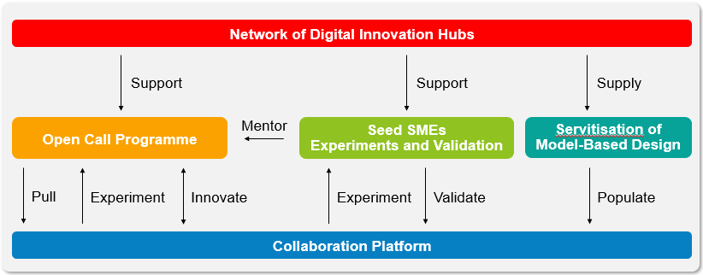

Figure 2: HUBCAP overall approach.

As mentioned above, HUBCAP will organize three sets of open calls to select and directly finance SMEs to develop, experiment, integrate, and deploy innovative Model-Based Design (MBD) and Cyber-Physical Systems (CPS) technology to create new products.

Working with the DIHs, SMEs will be able to access central funding for experiments via open calls as well as direct support. Members will make models, tools, training materials and expertise available to each other, either freely or on a commercial basis, making it faster and easier to access MBD CPS engineering tools.

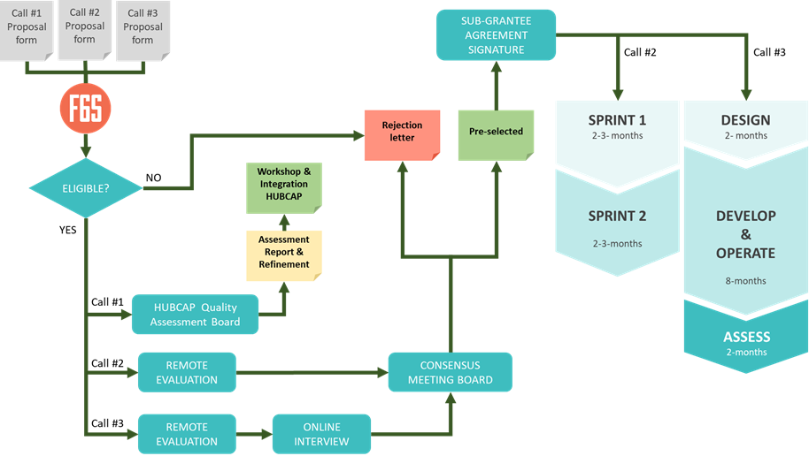

Figure 3: HUBCAP OCs overall concept and evaluation procedure.

The first open call, Call #1 PULL, will help individual SMEs get their assets on the platform. The second open call, Call #2 EXPERIMENT, will finance a consortium of SMEs to experiment with MBD. The third open call, Call #3 - INNOVATE, will finance a consortium of SMEs to innovate with MBD to create new products.

It is expected that new innovations will emerge towards the third year from the project third-party experiments through the EXPERIMENT and INNOVATE calls that will open later in the project timeline. Conversely, the PULL call is open from early in the project (with five regular deadlines) and has a budget dedicated to workshops helping partners get their assets into the collaboration platform.

IMPORTANTE: The information provided in this document is only binding in relation to Call #1.4 PULL, and applicants to further calls should comply with their respective guidelines and sub-grant agreements.

# General information

## Means of submission

The F6S platform (<https://www.f6s.com/hubcap-call-1.4-pull/apply>) will be the entry point for all applications’ submission to HUBCAP Open Call #1.4 PULL. Submissions received by any other channel will be automatically discarded.

Documents required in subsequent phases of the programme will be submitted via a dedicated channel, which will be indicated by HUBCAP consortium during the sub-granted projects execution.

## Language

**English** is the official language for HUBCAP open calls. Submissions done in any other language will not be evaluated. English is also the only official language during the whole execution of the HUBCAP programme. This means any requested submission of deliverable will be done in English in order to be eligible.

## Data protection

**Beneficiary´s personal data processing**

In order to process and evaluate applications, HUBCAP will need to collect Personal and Industrial Data. F6S Network Ireland Limited, as the Project Open Calls manager will act as Data Controller and will be responsible for ensuring that collection, processing and sharing of personal data and/or special categories of personal data are in compliance with Regulation (EU) 2016/679 of the European Parliament and of the Council of 27 April 2016 (the General Data Protection Regulation (“GDPR”)). F6S will therefore ensure the legal grounds for personal data processing, ensuring the contractual basis and taking required security measures in accordance with GDPR before processing and sharing any personal data and/or special categories of personal data.

Moreover, as personal data included in the applications need to be shared with the members of the HUBCAP Quality Assessment Board, F6S Network will assure the lawful basis for this sharing and processing, according to GDPR Article 6.1 (b) (“*Processing is necessary for the performance of a contract to which the data subject is party or in order to take steps at the request of the data subject prior to entering into a contract*”), namely promoting a data processing agreement with said HUBCAP members.

**Personal data embedded in the Beneficiary´s technology**

If the Beneficiary acts as data processor in respect of any personal data included and/or processed through the MBD Technology to be submitted to HUBCAP platform, the data controlling Beneficiary undertakes to bind any and all of their data processors, including if necessary F6S and/or any other HUBCAP consortium partner, to a data processing agreement in compliance with the applicable statutory data protection laws.

The F6S platform's system design and operational procedures ensure that data is managed in compliance with The General Data Protection Regulation (EU) 2016/679 (GDPR). Each applicant will accept the F6S terms to ensure coverage.

Please note that HUBCAP requests the minimum information needed to deliver the evaluation procedures. ***Annexes 4: Bank account information***, and ***Annex 5: Sub-grant Agreement Template***, are provided for reference and will only be requested if the SME is accepted in Call #1.4 PULL to integrate its assets within the HUBCAP Collaborative Platform.

Please refer to <https://www.f6s.com/terms> to check F6S platform data privacy policy and security measures.

## Origin of the funds

Any selected applicant will sign a dedicated Sub-Grant Agreement with the HUBCAP consortium.

**The funds attached to the Sub-Grant Agreement come directly from the funds of the European Project HUBCAP funded itself by the European Commission and remain therefore, property of the EU until the payment of the balance, whose management rights have been transferred to the project partners in HUBCAP via European Commission Grant Agreement Number 872698.**

As it can be seen in the Sub-Grant Agreement template (*Annex 5*), this relation between the sub-grantee and the European Commission through HUBCAP project carries a set of obligations to the sub-grantee with the European Commission. It is the task of the sub-grantee to accomplish them, and of the HUBCAP consortium partners to inform about them.

# Eligibility of applicants

HUBCAP invites market-oriented SMEs to introduce their MBD CPS within the HUBCAP Collaborative platform.

The HUBCAP Open Call #1 PULL will fund the integration of Single European mid-caps, SMEs and Micro SMEs as defined in EU law: EU recommendation 2003/361115. Each of these must be established in an EU Member State or in an Associated Country.

## Definition of SME

An SME will be considered as such if complying with the European Commission Recommendation 2003/361/EC[1] and the SME user guide[2].

## SME Eligibility Criteria

An SME is considered eligible for HUBCAP open call #1 PULL if it complies will ALL the following rules:

1. It is a legal entity established and based in one of the EU Member States or an H2020 Associated country as defined in H2020 rules for participation[3]:
2. It is a technology provider of MBD CPS technology.

Please note that a signed version of **Annex 4: Applicant Declaration of Honour** and **Annex 5: SME Declaration** are mandatory for the HUBCAP Open Call #1.4 PULL application.

## Application Eligibility Criteria

The following proposals eligibility criteria also apply:

1. Applications must have a **clear European dimension, facilitate HUBCAP based innovation** and contribute towards European Union digitization, **targeting clear economic and societal impact**.
2. **Each SME may submit only one (1) asset application at each HUBCAP call #1.4 PULL. Multiple submissions to call #1.4 will not be accepted**. In case the afore mentioned SME is not selected it can participate again in one of the other PULL calls, but only if it uses a different application asset
3. **The maximum amount of direct funding that an SME may receive via HUBCAP for Open Call #1.4 PULL is 1000 EUROs.**

# HUBCAP Open Call #1.4 PULL

The following chapter shows all the relevant information for a successful application to Call #1.4 PULL.

## Funding Scheme

The Open Call #1.4 PULL will fund individual SMEs with Model-Based Design (MBD) Cyber-Physical System (CPS) technology products and services that can be integrated in HUBCAP Collaborative Platform.

The selected products and services will enlarge and enrich the pool of technology tools/offers of HUBCAP. The beneficiaries from Call #1.4 PULL can subsequently also be funded by collaborating with other SMEs and together apply to HUBCAP Call #2 EXPERIMENT.

Individual SMEs will receive a total fund of 1.000€ (one thousand Euro) to introduce their technologies and participate in a Workshop. Participation in the workshop is mandatory.

To avoid conflicts of interest, applications will not be accepted from persons or organisations who are partners in the HUBCAP consortium or who are formally linked in any way to partners of the consortium. All applicants will be required to declare that they know of no such potential conflicts of interest that should prevent them from applying.

Third parties receiving the sub-grant from HUBCAP through the Open Call will not become part of the HUBCAP project consortium and do not accede to the HUBCAP Grant Agreement; therefore, an EU Participant Identification Code (PIC) is not required. Likewise, the third parties will not become parties to the Consortium Agreement entered among the HUBCAP consortium partners.

HUBCAP funding is results-driven, provided as vouchers in a lump sum way. As such, there is no need for a traditional administrative-justification system (e.g., counting hourly dedication or calculating workload), but getting the funding is associated with the full achievement of the relevant milestone.

## Timeline

Submission to Call #1.4 PULL will be enabled on the **7th of September 2021** and end on the **4th of** **November 2021 at 17:00 CET** time (Brussels time). Figure 4 shows the different activities and respective timelines expected for Call #1.4 PULL.

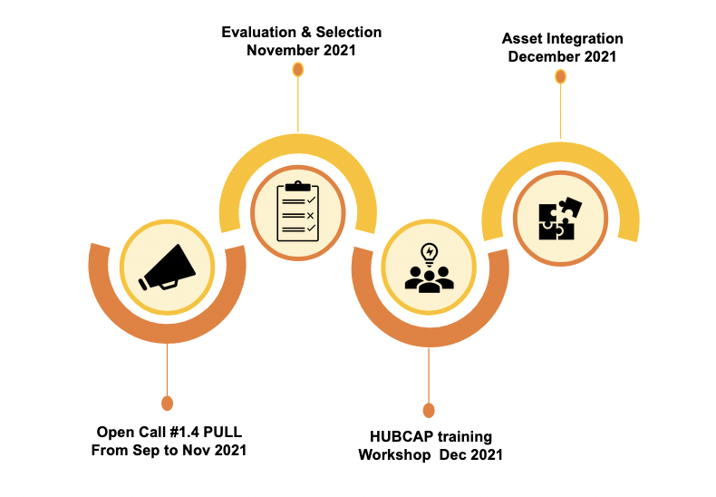

Figure 4: Open Call #1.4 PULL activities timeline.

The evaluation process will be undertaken after the deadline for applying to Call #1.4 PULL is concluded, to allow a fair process. After the evaluation process a selection period will follow, and its duration will be determined taking into consideration the final date for the HUBCAP Workshop (minimum two weeks before the workshop takes place).

Each Workshop will have a duration of one day only and its goal is to clarify how the process of asset integration will occur and to provide information about what is expected from each beneficiary SME after the respective asset integration is completed. The HUBCAP Workshop should be held on a F2F basis but due to the current Covid-19 situation the HUBCAP Consortium may agree on conducting the Workshop online, the same will be held in December 2021. Although, more detailed information concerning the Workshop organisation will be shared among the beneficiary SMEs.

The integration of the assets will go as follow: it will take place after the workshop participation on the part of the selected SMES from Call #1.4 PULL. For participation in the Call 1.4 PULL, the public information provided in the application form (of selected applicants) will be used in a simplified portfolio in the HUBCAP project website (not platform). The selected applicants will participate in a one-day online workshop in which they will be informed about the future integration of the asset in the HUBCAP platform. The participation in the Call #1.4 programme is officially closed then (therefore, the funding will be provided upfront). Nevertheless, the asset provider has the obligation to insert the asset in the HUBCAP platform. As such, the asset provider will be able to sell their technologies on the occasion of Call 2.2 EXPERIMENT. The HUBCAP team will be available to support on such occasions, and may circulate a form/template to facilitate this process, which the asset provider will have to fill in.

## Application, Selection and Payment procedures

Interested applicants should register at F6S ([www.f6s.com](http://www.f6s.com)), to be able to access the HUBCAP F6S page (<https://www.f6s.com/hubcap-call-1.4-pull/apply> ). This will be the central interface for managing the applications.

### Submission

Applicants are invited to submit their applications on the F6S platform. Each applicant will have the following documentation to support their asset application:

* **Annex 1: Guidelines for Applicants Open Call #1.4 PULL**, this document.
* **Annex 2: Applicant Declaration of Honour**, which declares that all conditions of the Open Call #1.4 PULL are accepted by an SME legal representative.
* **Annex 3: SME Declaration**, which evaluates the status of the SMEs participating at an open call #1.4 PULL.
* **Annex 4: Bank account information**, which collects information on the applicant(s)’ bank account where the HUBCAP payments will be sent to.
* **Annex 5: Sub-grant Agreement Template**, which provides a template of the sub-grant agreement that the successful applicants will be requested to sign.
* **Annex 6: Template for H2020 Financial Support to Third Parties,** which contains the formal announcement to be published in the EU portal.
* **Frequently Asked Questions & answers** published at the community feed (<https://www.f6s.com/hubcap-call-1.4-pull/discuss> ).

Applicants are expected to provide complete, accurate data and contact details.

### Asset Application Preparation

Please follow the steps:

1. For the application preparation, the individual SMEs are requested to apply online and answer to all mandatory questions (with no exception) at: <https://www.f6s.com/hubcap-call-1.4-pull/apply>
2. All applicants must accept the terms and conditions and must sign and upload to the F6S platform the completed ***Annex 2:*** ***Applicant Declaration of Honour*** and ***Annex 3:*** ***SME Declaration***. Applicants who fail to do so will not be eligible.
3. Be concrete and concise. Questions have character limitations. Please examine all the open call documents and for more information please go to HUBCAP project website ([www.hubcap.eu](http://www.hubcap.eu))
4. It is highly recommended to submit your asset application well before the deadline. If the applicant discovers an error in the asset application, and provided the call deadline has not passed, the applicant may request the F6S HUBCAP team to enable them to re-submit the asset application (for this purpose please contact us at [support@f6s.com](http://support@f6s.com)). **However,** **HUBCAP is not committed that resubmission in time will be feasible in case the request for resubmission is not received by the F6S HUBCAP team at least 48 hours before the call deadline.**

**It is strongly recommended not to wait until the last minute to submit the asset application. Failure of the asset application to arrive in time for any reason, including network communications delays or working from multiple browsers or multiple browser windows, is not acceptable as an extenuating circumstance. The time of receipt of the application as recorded by the submission system will be definitive.**

### Asset Application Reception

Submissions will be done ONLY via the F6S platform on [www.f6s.com/hubcap-call-1.4-pull/apply](http://www.f6s.com/hubcap-call-1.4-pull/apply). A full list of applicants will be drafted containing their basic information for statistical purposes and clarity (which will be also shared with EC for transparency).

The asset application reception will close on **4th November 2021 17:00 CET (Brussels time)** There will not be any deadline extensions unless a major problem caused by the F6S platform and not by the applicants, makes the system unavailable.

## Selection Process

### Eligibility

An automatic filtering to discard non-eligible asset applications will be applied. Eligibility criteria check will verify:

1. the applicant is a legal entity eligible for EC funding under the rules of H2020 [Y/N],
2. the applicant entity is an MBD CPS SME provider [Y/N],
3. the application is written in the English Language [Y/N],
4. the existence of the same entity multiple asset application under the call #1.4,
5. the alignment with HUBCAP call for asset integration,
6. all required documentation signed and submitted: ***Annex 2: Applicant Declaration of Honour*** and ***Annex 3: SME Declaration*** submitted correctly [Y/N].

Asset applications being marked as non-eligible will get a rejection letter that will include the reasons for being catalogued as non-eligible. No further feedback on the process will be given.

### Internal remote evaluation

HUBCAP Call #1.4 PULL will execute a trustworthy evaluation process.

Remotely and within F6S platform, the **HUBCAP Quality Assessment Board, composed by selected people within the HUBCAP DIHs partners, will be the evaluators** of Call #1.4 PULL. They have the best experience in HUBCAP MBD CPS technologies, and will evaluate each asset application, scoring it based on the following evaluation criteria:

* ***Criterion 1: Concept fit*** - Business fit to HUBCAP scope and relevance to CPS domains.
* ***Criterion 2: Technology*** - Innovation, asset specification and technical capacity of a TRL 5 to 9 and IPR.
* ***Criterion 3***: ***Future use*** - Benefits of the technology for end users and exploitation potential.

Each criterion will have a mark between 1 and 10. Half point scores are not given. For each criterion under examination, score values will indicate the following assessments:

***1-2: Poor.*** The asset application fails to address the criterion under examination or cannot be judged due to missing or incomplete information.

***3-4: Fair.***The criterion is addressed but in an unsatisfactory manner. There are serious inherent weaknesses.

***5-6: Good.***While the asset application broadly addresses the criterion, there are minor weaknesses that would need correcting.

***7-8: Very Good****.* The asset application addresses the criterion well, although certain improvements are possible.

***9-10: Excellent****.* The asset application successfully addresses all relevant aspects of the criterion in question. Any shortcomings are minor.

The Quality Assessment Board will issue an Evaluation Summary Report (ESR) for each asset application. All applications must reach the minimum **threshold of 5 in each category**, in order to be considered for selection.

### Final Selection

The selection of the individual SMEs asset application will be a simple process, based on the prior criteria presented and based on the HUBCAP Quality Assessment Board evaluation report.

The Quality Assessment Board will follow specific evaluation guidelines and templates, as well as they will be asked to sign non-conflict of interest declaration.

All asset applications will receive an acceptance or rejection letter together with an anonymized version of their asset applications ESR.

### Sub-Grant Agreement Preparation

After Open Call #1.4 PULL internal evaluation conclusion and SMEs selection, the HUBCAP coordinator will start the Sub-Grant Agreement preparation in collaboration with the applicant coordinator that have been evaluated. Sub-Grant Agreement preparation will go via an administrative check (and potentially into technical or ethical/security negotiations) based on evaluators’ comments. On a case-by-case approach, a phone call or teleconference may be needed for clarification. The objective of the Sub-Grant Agreement preparation is fulfilling the legal requirements between the HUBCAP consortium and every SME beneficiary of the Call #1.4 PULL. There will be an inclusion of the comments (if any) in the Evaluation Summary Report of the asset application and mapping to the Sub-Grant Agreement.

To validate the status information of the SME, the following documents will be required:

* **SMEs declaration:** signed and stamped. In the event the applicant declares being non-autonomous, the balance sheet and profit and loss account (with annexes) for the last period for upstream and downstream organizations should also be provided.
* **Legal existence**. Company Register, Official Gazette or other official document per country showing the name of the organisation, the legal address and registration number and a copy of a document proving VAT registration (in case the VAT number does not show on the registration extract or its equivalent).
* In cases where the **number of employees** **and/or the ownership is not clearly identified**: any other supporting documents which demonstrate headcount and ownership such as payroll details, annual reports, national regional association records, etc.
* **SME Bank account information:** The account where the funds will be transferred will be indicated via a form signed by the SME legal representative and the bank representative. The account should be a business bank account of the SME.

It should be emphasised that each **SME should provide at Sub-Grant agreement preparation time a valid VAT[4]. Failure to provide the VAT number will automatically result in proposal rejection**.

The request of the above documentation by the HUBCAP consortium will be done including deadlines. In general, the Sub-Grant Agreement negotiation should be concluded within two weeks. An additional week may be provided by the HUBCAP coordinator in case of significant reasoning. In case the negotiations have not been concluded within the above period, the application is automatically rejected, and another SME applicant will be given the opportunity of acceptance.

### Sub-Grant Agreement Signature

Two weeks before the workshop the participants must submit the signed agreements to the HUBCAP consortium using the email address: [oc.administrative@hubcap.eu](mailto:oc.administrative@hubcap.eu)

Failure to receive the electronic version of the documents means that the applicant no longer wants to participate in the workshop and the voucher may be granted to other applicants.

### Redress process

Within 3 working days of the delivery of a rejection letter considering the asset application as non-eligible or an ESR, a proposer may submit a request for redress if s/he believes the results of the eligibility checks have not been correctly applied, or if s/he feels that there has been a shortcoming in the way his/her asset application has been evaluated that may affect the final decision on whether to enter the Call #1.4 PULL or not.

In that case, an internal review committee of the HUBCAP consortium will examine the request for redress. The committee's role is to ensure a coherent interpretation of such requests, and equal treatment of applicants.

Requests must be:

* Related to the evaluation process or eligibility checks,
* Clearly describe the complaint,
* Received within the time limit (3 working days) from the reception of a rejection letter considering the asset application as non-eligible or the ESR information letter delivered,
* Sent by the SME legal representative that has also submitted the asset application.

The committee will review the complaint and will recommend an appropriate course of action. If there is clear evidence of a shortcoming that could affect the eventual funding decision, it is possible that all or part of the asset application will be re-evaluated.

Please note:

* This procedure is concerned only with the evaluation and/or eligibility checking process. The committee will not call into question the scientific or technical judgement of appropriately qualified experts.
* A re-evaluation will only be carried out if there is evidence of a shortcoming that affects the final decision on whether to fund it or not. This means, for example, that a problem relating to one evaluation criterion will not lead to a re-evaluation if an asset application has failed anyway on other criteria.
* The evaluation score following any re-evaluation will be regarded as definitive. It may be lower than the original score.

Only one request for redress per asset application will be considered by the committee. All requests for redress will be treated in confidence and must be sent to Project Coordinator via the F6S platform.

# Responsibilities of beneficiaries SMEs

The selected SMEs of Call #1.4 PULL are indirectly beneficiaries of European Commission funding. As such, they are responsible for the proper use of the funding and ensure that the recipients comply with obligations under H2020 specific requirements as described in Horizon 2020 - the Framework Programme for Innovation Action 2014-2020 (Digitising and transforming European industry and services: digital innovation hubs and platforms). The obligations that are applicable to the recipients include[5] accomplishing the proper integration of its technology with the HUBCAP ecosystem and to travel and participate in the HUBCAP Workshop, in an appropriate manner. Appropriate manner means that the participant will comply with the house rules in case of an onsite meeting and in general to the meeting rules.

The obligations of the beneficiary SME are set forth in the ***Annex 5: Sub-Grant Agreement***.

# Contacts

The HUBCAP consortium will provide information to the applicants only via the F6S blog, so that the information (question and answer) will be visible to all participants.

No binding information will be provided via any other means (e.g., telephone or email).

More info at: [www.hubcap.eu](http://www.hubcap.eu/)

Apply via: <https://www.f6s.com/hubcap-call-1.4-pull/apply>

F6S support team: [support@f6s.com](mailto:support@f6s.com)

Online Q&A: <https://www.f6s.com/hubcap-call-1.4-pull/discuss>

HUBCAP support team: [info@hubcap.eu](mailto:info@hubcap.eu)

# References

1. Digital Innovation Initiatives based on European Networks of Competence Centres in H2020, available online at <https://smartanythingeverywhere.eu/smart-anything-everywhere/>
2. REGULATION (EU) No 1290/2013 OF THE EUROPEAN PARLIAMENT AND OF THE COUNCIL of 11 December 2013 laying down the rules for participation and dissemination in "Horizon 2020 - the Framework Programme for Research and Innovation (2014-2020)" and repealing Regulation (EC) No 1906/2006
3. EUROPEAN COMMISSION, Directorate-General for Communications Networks, Content and Technology, “Guidance note on financial support to third parties under H2020”, Annex K. “Actions involving financial support to third parties”, <http://ec.europa.eu/research/participants/data/ref/h2020/other/wp/2016_2017/annexes/h2020-wp1617-annex-k-fs3p_en.pdf>
4. H2020 Call Objective DT-ICT-01-2019 TOPIC: Smart Anything Everywhere Initiative, <https://ec.europa.eu/research/participants/portal/desktop/en/opportunities/h2020/topics/ict-01-2019.html>

1. European Commission Recommendation 2003/361/EC. <http://eur-lex.europa.eu/LexUriServ/LexUriServ.do?uri=OJ:L:2003:124:0036:0041:en:PDF>
2. SME definition <http://ec.europa.eu/enterprise/policies/sme/files/sme_definition/sme_user_guide_en.pdf>
3. Association to Horizon 2020 is governed by Article 7 of the Horizon 2020 Regulation. The list of associated countries is available at: <http://ec.europa.eu/research/participants/data/ref/h2020/grants_manual/hi/3cpart/h2020-hi-list-ac_en.pdf>
4. To be checked at European Commission services such as <http://ec.europa.eu/taxation_customs/vies/>
5. The obligations described here are not binding and may be modified, refined or additional obligations may be inserted during the sub-grant agreement negotiation if needed.